KEY INSTANT RECALL FACTS

YEAR 5 – SPRING 1

**I KNOW ALL PRIME NUMBERS WITHIN 20 AND SOME SQUARE NUMBERS.**

By the end of this term, children should be able to recall all prime numbers within 20 and some square numbers.

**Success Criteria:**

* I can identify all prime numbers up to 20.
* I can find a square number

**Prime numbers are numbers that have only 2 factors: 1 and themselves.**

**A factor is a number that divides into another number exactly OR where 2 numbers are multiplied together to make a product.**

**For example 16 is NOT a prime number because:**

**1 x 16 = 16**

**2 x 8 = 16**

**4 x 4 = 16**

**3 IS a prime number because only 3 x 1 = 3 NOTHING ELSE DOES!**

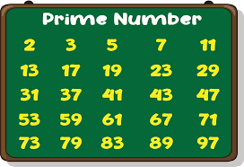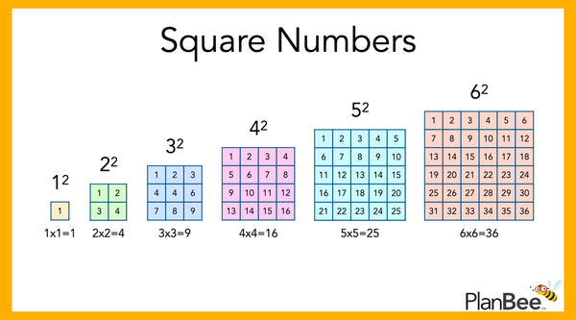

**TOP TIPS**

The secret to success is practising little and often. Use time wisely!

Can you practise these KIRFs on the way to school either walking or by car? You don’t need to practise them all at once: you could have a fact of the day!

**Try these links:**

<https://www.transum.org/maths/game/primes/pick.asp>

<https://mathsbot.com/puzzles/findThePrimes>

<https://www.mathematics-monster.com/tests/whack_a_mole_square_numbers.html>

<https://www.sheppardsoftware.com/math/numbers/fruit-splat-squares-cubes/>

**Or grab some worksheets from class and take them home!**