KEY INSTANT RECALL FACTS

YEAR 4 – SPRING 1

**I KNOW MULTIPLICATION AND DIVISION FACTS FOR 11x AND 12x tables.**

By the end of this term, children should be able to recall all multiplication and division facts for the 11- and 12-times tables.

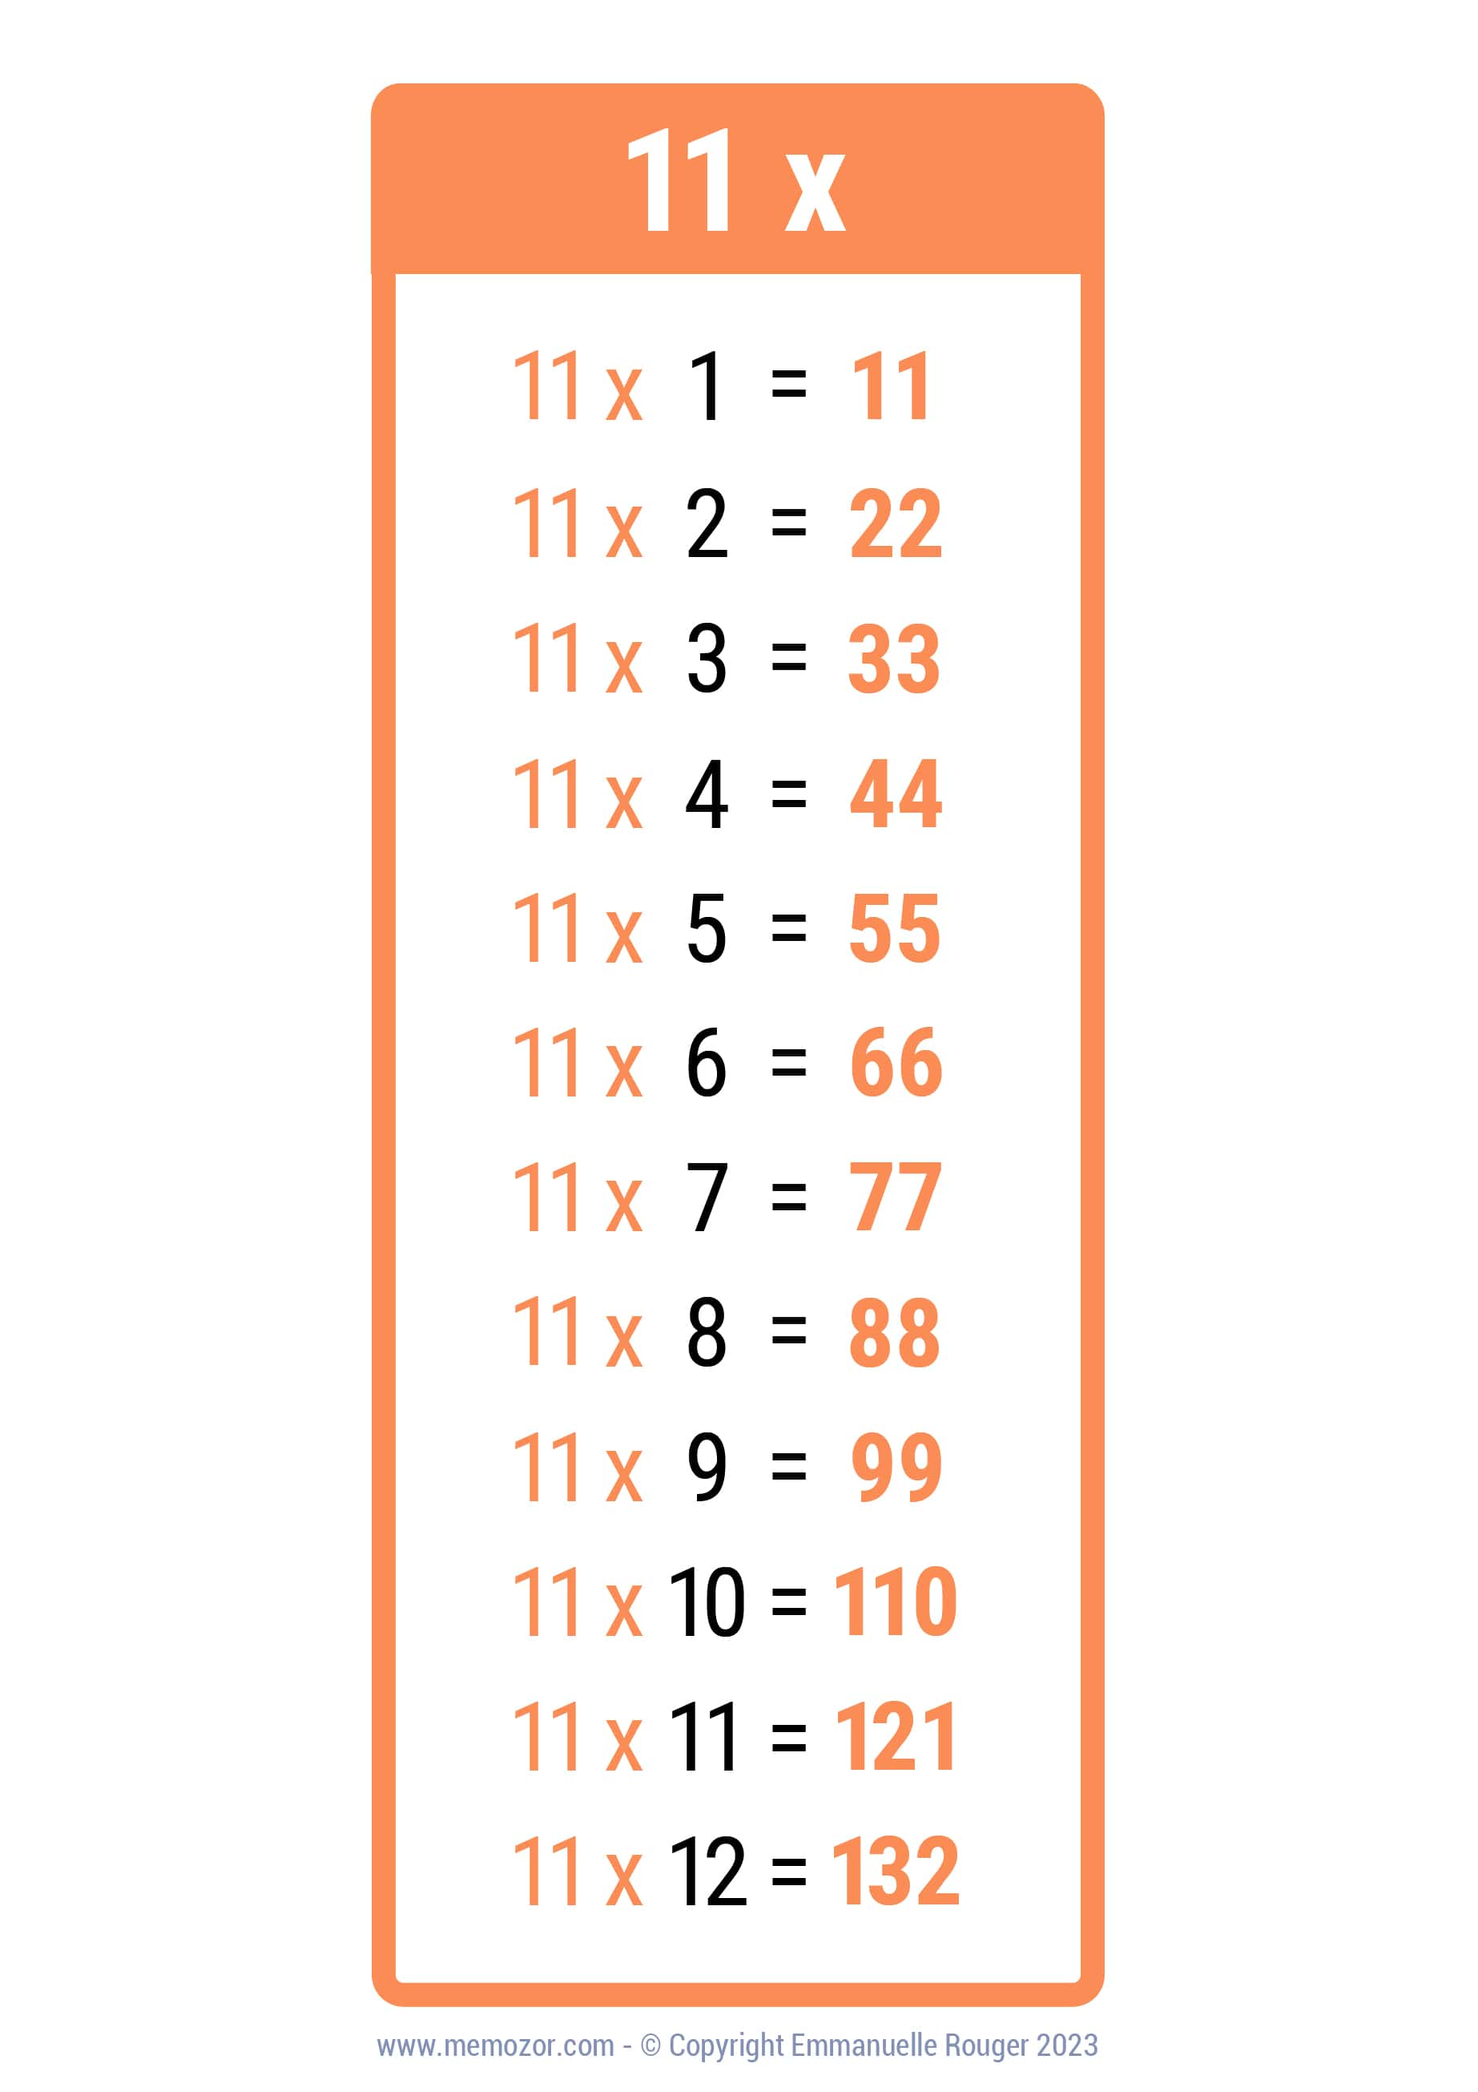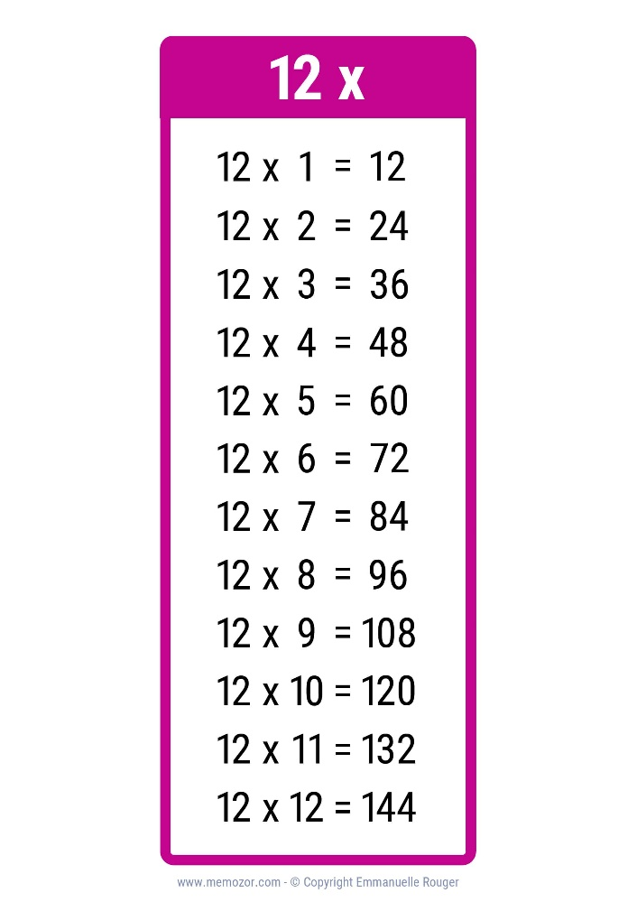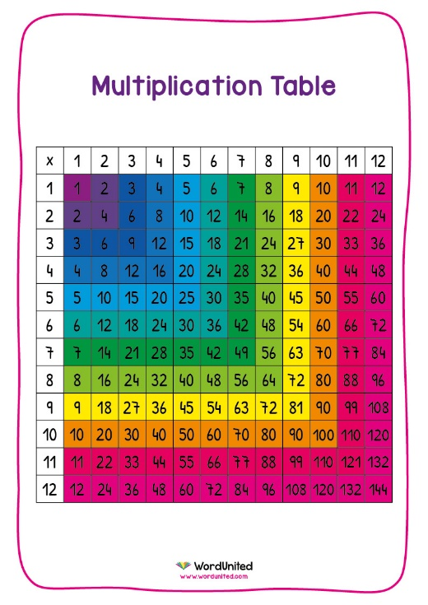

**Success Criteria:**

* I can recite both the 11- and 12-times tables in order.
* I can answer multiplication and division questions about the 11- and 12- times tables.

**TOP TIPS**

The secret to success is practising little and often. Use time wisely!

Can you practise these KIRFs on the way to school either walking or by car? You don’t need to practise them all at once: you could have a fact of the day!

**Try these links:**

<https://www.timestables.co.uk/>

(then click onto the 11- or 12- times tables)

<https://www.topmarks.co.uk/maths-games/7-11-years/times-tables>

<https://www.youtube.com/watch?v=dNHC-oU8tt8>

An 11- times table song.

<https://www.youtube.com/watch?v=9TSbNpPW1E4>

A 12- times table song.

**Or grab some worksheets from class and take them home!**