Key Instant Recall Facts (KIRFs)
A guide for Parents
KIRF’s (Key Instant Recall Facts) are pieces of mathematical knowledge that we want the children to learn off-by-heart or be able to work out very quickly (rapid recall).
They are designed to support the development of the mental skills that underpin mathematics and are particularly useful when calculating, be it adding, subtracting, multiplying or dividing. KIRFs will include facts such as number bonds, counting on or back, times tables, equivalence of units of measure, factors and square/prime/cubed numbers.
Each year group as allocated key facts to focus on - a new fact per half term - in line with age related expectations that build on term after term, year after year. This will give your child a stronger foundation for which to build their mathematical understanding.
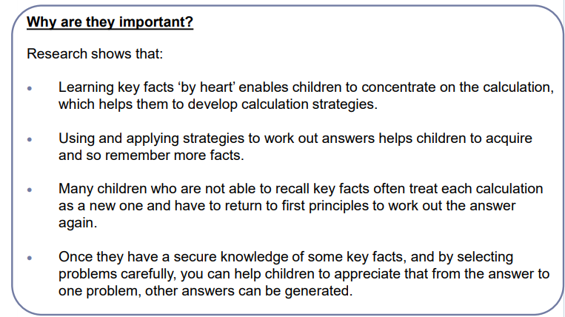
Each half term, children are given KIRFs to practice and learn at home as well as the work in school. These are sent home on A4 sheets and include practical ideas for you as parents/carers to assist your child in grasping the key facts.
These KIRFs are designed for children to learn in a fun, practical way and should be taken as part of their regular homework schedule in order to gain rapid recall and fluency.
Your child is currently working on the Autumn 1 KIRF for their year group. I hope you enjoy working alongside your child. Should you have any questions regarding KIRFs then please contact me via the school.

Yours faithfully,

EMILY RANDLE Maths Subject Lead

KEY INSTANT RECALL FACTS
YEAR 5 – SPRING 1

I KNOW ALL THE PRIME NUMBERS WITHIN 20 AND SOME SQUARE NUMBERS.
By the end of this half term, children should be able to fluently calculate how to halve an even number and double a 2-digit number.
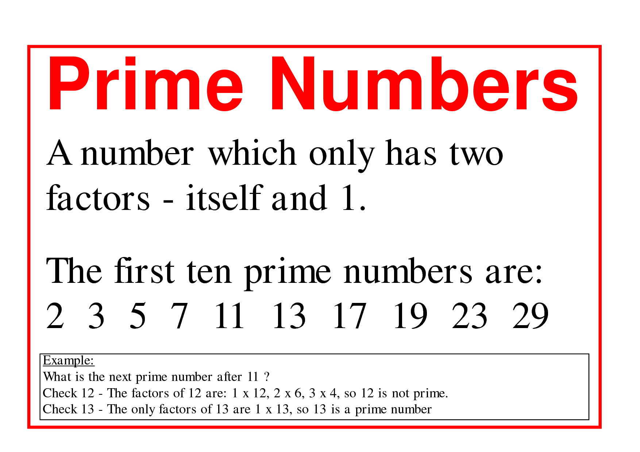
Success Criteria:
- Work out the factors for a number
- If the number only has a factor of itself and 1 – it is a prime number!
Factors of 6 = 1, 2, 3, 6
Factors of 7 = 1, 7
Factors of 7 = 1, 7

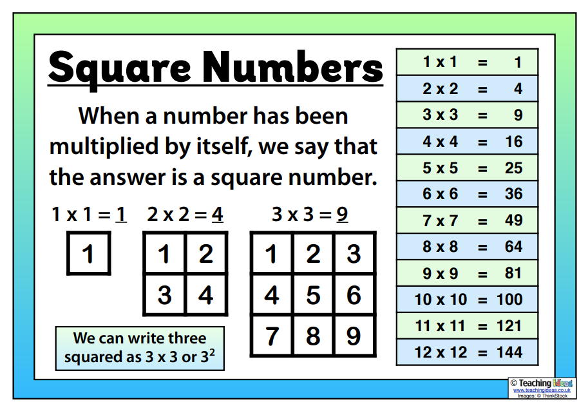

TOP TIPS
The secret to success is practising little and often. Use time wisely! Can you practise these KIRFs on the way to school either walking or by car? You don’t need to practise them all at once: you could have a fact of the day!

Try these links:
https://www.topmarks.co.uk/maths-games/hit-the-button (then click onto square numbers)

https://wordwall.net/en-gb/community/square-numbers-game

https://mathsframe.co.uk/en/resources/category/181/year-6-block-b-recognise-that-prime-numbers-have-only-two-factors-and-identify-prime-numbers-less-than-100-find-the-prime-factors-of-twodigit-numbers

or
grab some worksheets in class and take them home!

