CHAIPEL CLASS – How did World War 2 affect different people in society?
Daily/Weekly Tasks
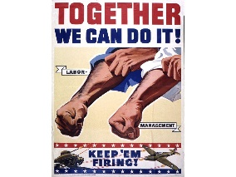
Reading, reading and more reading!
You should be aiming to read 5 times per week, but reading every day is better!

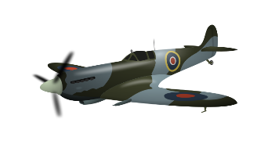
KIRFs: Y5: PRIME AND SOME SQUARE NUMBERS Y6: SQUARE, SQUARE ROOT AND PRIME NUMBERS

CURRICULUM SPELLINGS
A copy of Y3/4 and Y5/6 is attached below.
Enquiry Question Homework Tasks
READING  Goodnight Mr Tom,  Adolphus Tips,  Letters from the Lighthouse. | LITERACY  Write a newspaper report about a bombing in your area. | MATHS  Find out the costs of on rationed items. How much would you spend on food weekly? | SCIENCE/TECH  Research what the blackout was.  What would you have invented to combat this problem? | MUSIC  Write a song to keep everybody’s spirits up during the war. | PSHE  Research your family tree and find out which family members were alive during WW2.
LITERACY  Write instructions/  advice about how to survive during an air raid | SCIENCE  Write your name in Morse Code.  Can you write a secret message to help the British Troops? | MATHS  Play a game of battleships!  Create a graph comparing the sizes of the armies in WW2 | PSHE  Research the life of Anne Frank. What rights do we have now that she did not. | ART/DT  Create a propaganda poster.  Research a WW2 recipe and make it at home. | DT  Make an air raid or Anderson shelter.  What materials di you use?

