**Chaipel’s Anti- Bullying poem 2023**

The news on the ground is that bullying is around,

So what can we do to stop it?

So let’s shout it out loud

Be strong and be proud,

And don’t keep it hidden in your pocket!

If you see someone who feels a bit down,

Go up to them and turn that frown upside down,

But if you see someone being nasty and mean,

Tell that bully, “It’s time to come clean!”

It’s wrong to be bad and make someone feel sad,

Why don’t you try being kind?

Try saying, “SORRY!” to the people you have hurt,

And keep this message in mind.

If you see something wrong – MAKE SOME NOISE!

Talk to your adults and friends,

REMEMBER - Shout out and be in no doubt,

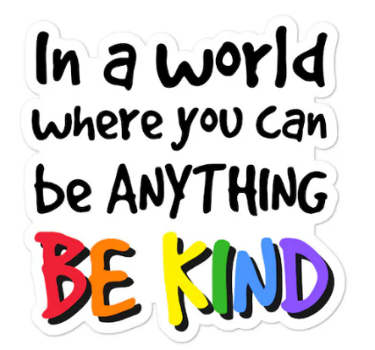And let the bullying end.

