

POLPERRO PRIMARY ACADEMY

OPEN MORNING

**Looking for a Primary School for September 2024?**

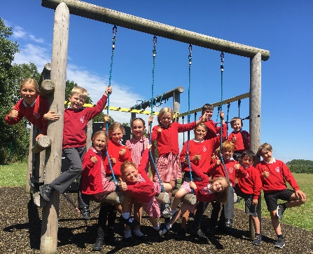

Polperro Primary Academy is a happy and thriving school for children age 2-11 years and is often described as 'somewhere special' by visitors, parents and children alike. The school is rated good by Ofsted who noted that ‘…all pupils are warmly welcomed, feel safe and secure and can excel.’

With 100 children aged 2 - 11, we offer the ideal transition from nursery to primary education and attract children throughout Looe, Pelynt, Polperro and neighbouring villages. We are very proud of our School and invite you to find out more by coming along to our **Session on Wednesday 15th November (9:30 – 11:00 am)**, where you can meet our Head of School and staff and have a tour of the School. Alternatively visit our website for more information.

We have wonderful staff and facilities, including an outdoor swimming pool, and we look forward to meeting you soon.

To arrange an appointment, simply call us on **01503 272 249.**

Polperro Primary Academy [www.polperroprimary.co.uk](http://www.polperroprimary.co.uk)

Brentfields, Looe, 01503 272249

Cornwall, PL13 2JJ